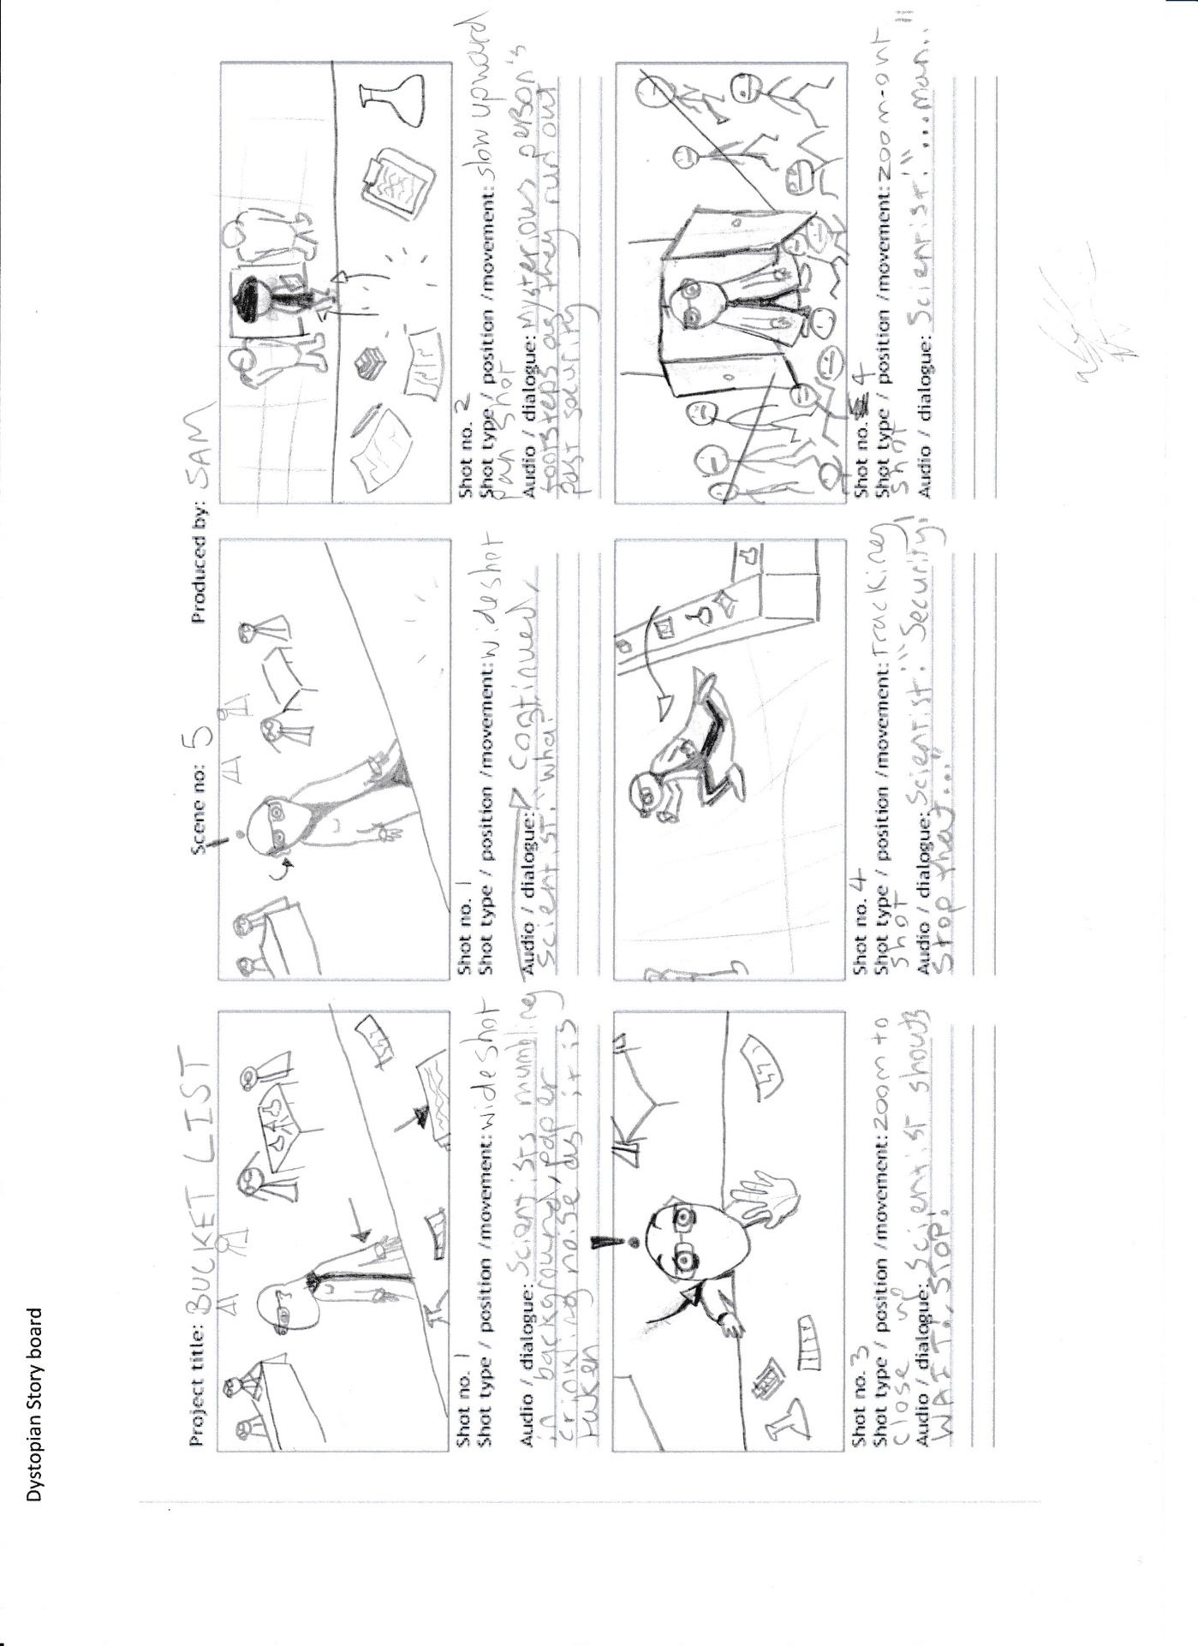

Use of Mise en Scene as the actor runs across the set allows the director to tell more of the story through visual clues such as details on scientists desks and computer screens

Diagetic Sound (actual sound) detailed here.

A sound that is made by something seen on screen

Dystopian Storyboard analysis of storyboard techniques

Film title

Reference to lines in the script helps

Description of camera movement

The first scene is a wide shot to take in the whole set up

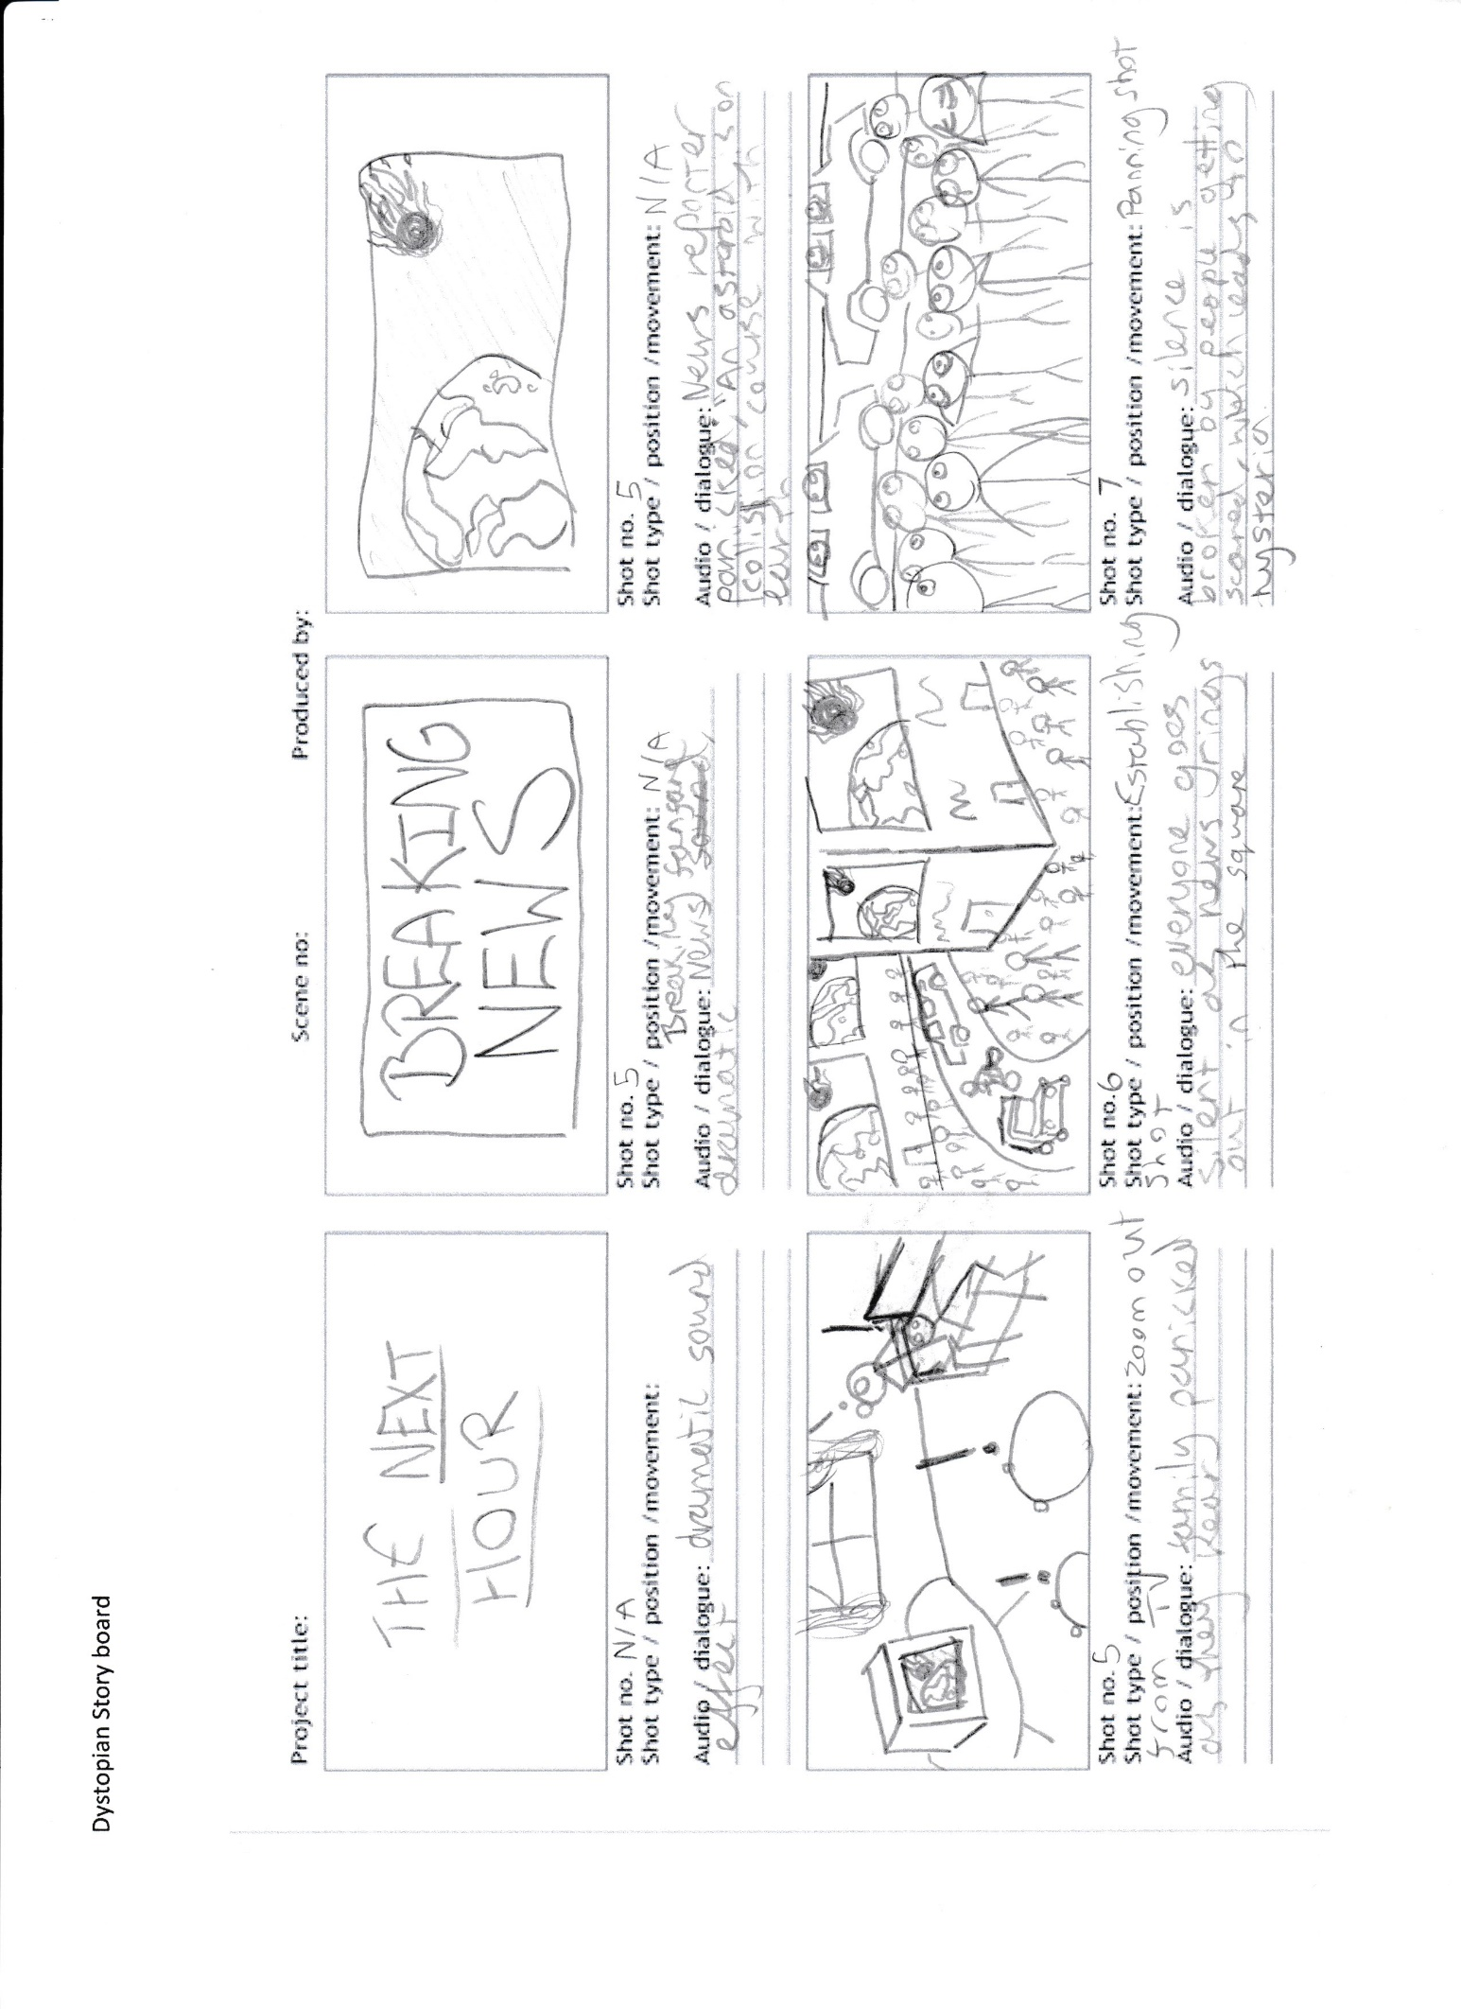

Mise en scene details family life disrupted

Close ups of crowd show the rising panic

Crowd scenes need detailed planning

Special FX shot of asteroid heading to Earth is also added in post production

Caption added in post production therefore no need to shoot

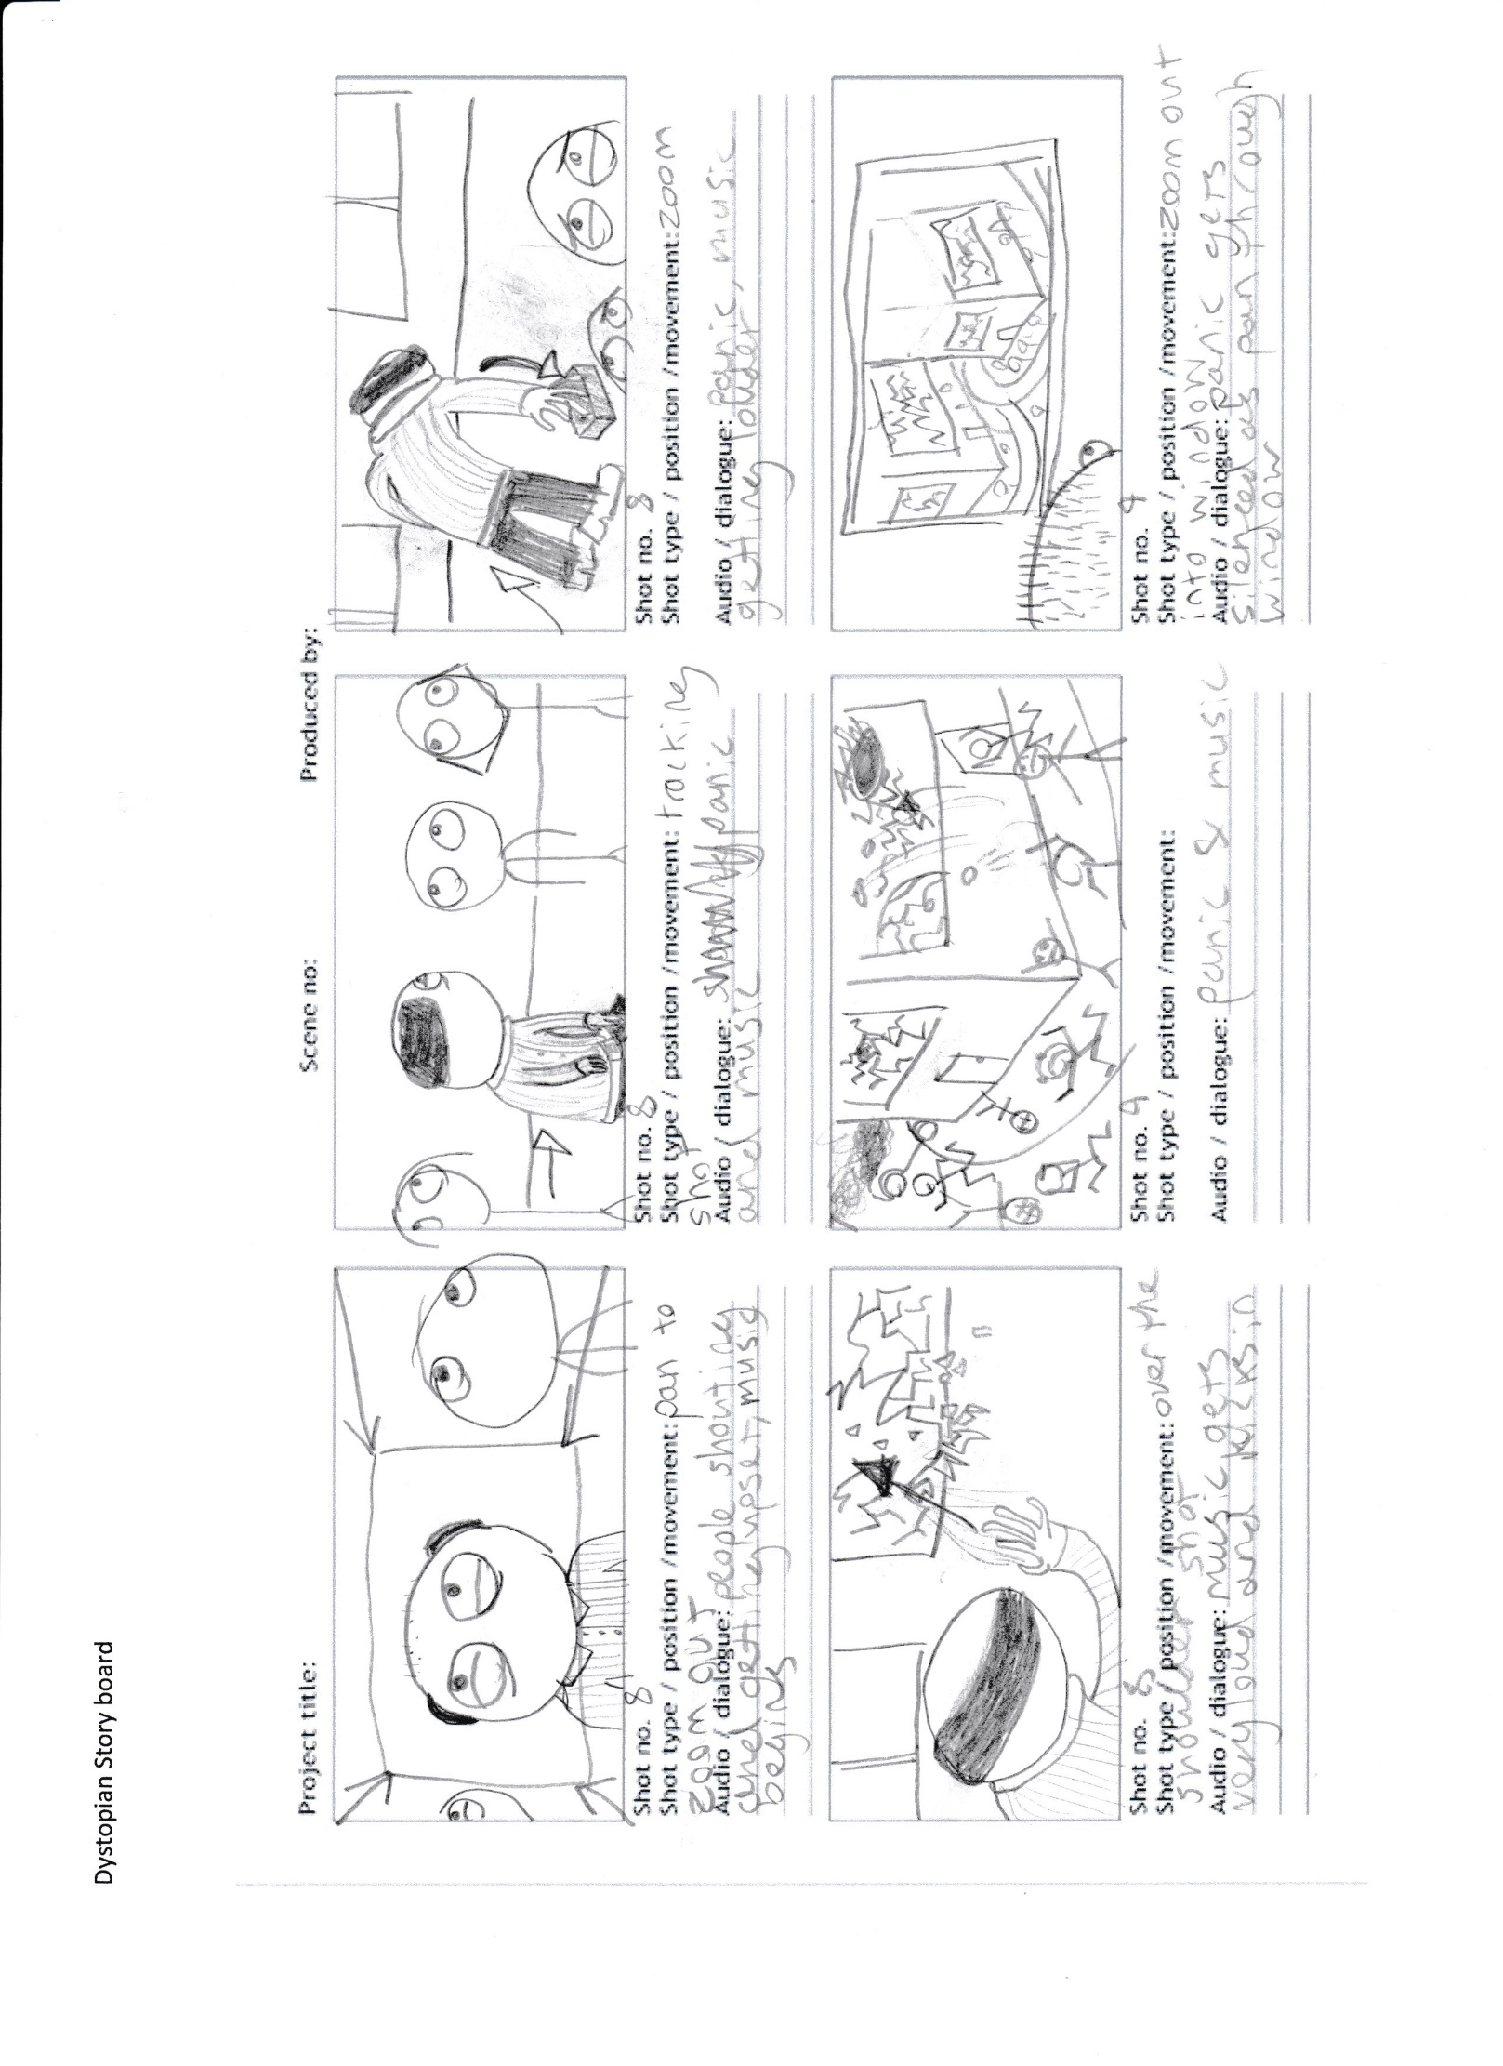

Through the window shot

Camera direction

Music direction here will help to ensure the composer knows when to build to crescendo

Close up shots of people reacting

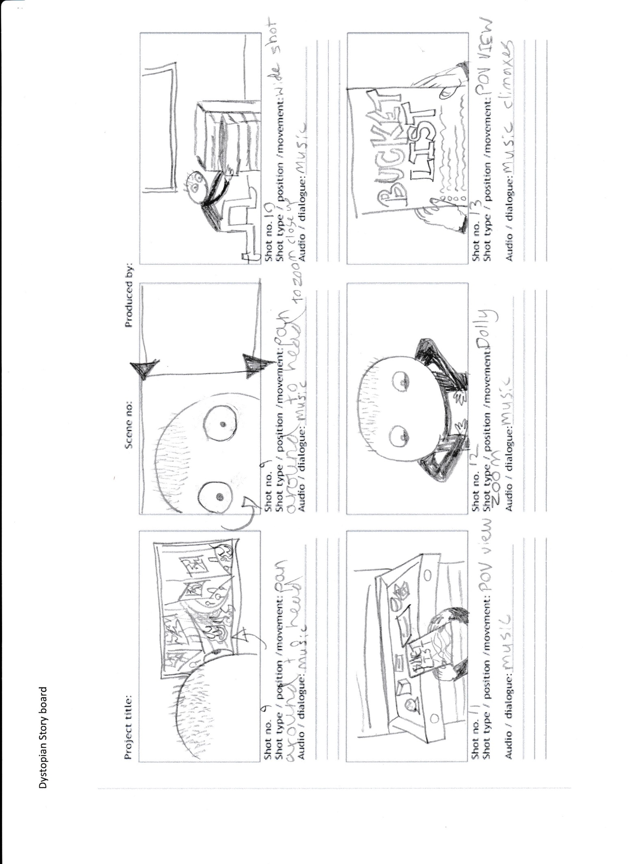

Mise en scene shows more about main characters life through objects

Non diagetic sound ie not linked to screen action

A dolly zoom is a camera technique where the camera moves closer or further away from the subject whilst simultaneously adjusting the camera angles to keep the subject in the shot

Point of View shot shows importance of key shot emphasizing name of film

Sequencing that scenes are shot in must be recorded to help with organisation of rushes when editing

Evaluation of Dystopia TV show storyboard

I have used the format for my story board that tells the story the most clearly and allows for different explanations of the way each scene will be shot. I have added descriptions of the cinematic techniques used and why I have used them to explain what I was thinking.

I have included examples of camera angles and different types of shot, camera movements, contents of each shot is drawn in rough cartoon style to explain what the shot will look like but not all the detail. I have also included an explanation and examples of diagetic and non-diagetic sound and where the music will be used to add to the dramatic effect.

I have identified where the mise en scene can be used to tell more of the story through visual clues and set dressing that can help establish character details that would be hard to explain in words.

Unlike my advert storyboard this format allows me to say far more about the camera shots and sound and give more detail which is necessary with drama.

I could have made it better by adding more detail about post production such as when a fade or dissolve could be used to good effect. This would have helped the editor and director know what footage they needed to get.

My TV show is not going to be cheap to make because it involves special effects ( asteroid etc) and large crowd scenes shot in an inner city but with each shot planned and designed in advance the production costs can be kept within budget.